TIBCO EMS SERVER 8.2 DB Data store Configuration

Requirements:

1. Hibernate Core for Java and related JAR files.
2. A database server that is supported by Hibernate, the corresponding dialect, and the appropriate JDBC driver.
3. A username with read-write permissions and a password to the database server.

Steps for configuring database stores:

1. Enable the database store feature in the tibemsd.conf by setting parameters:

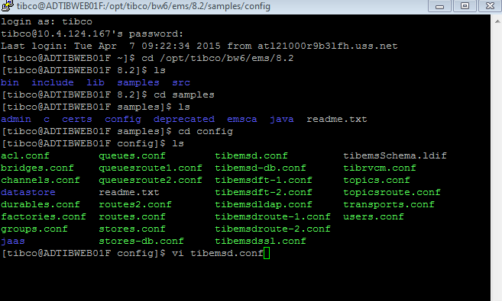

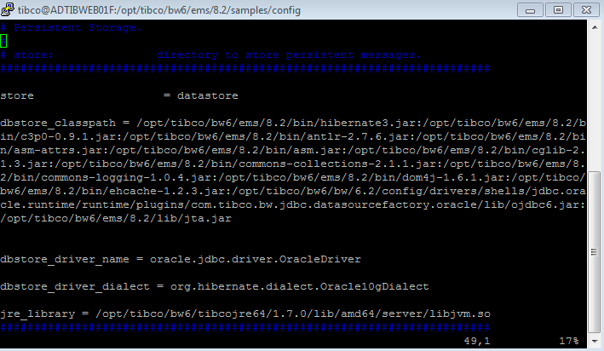

1. Setup and configure stores in stores.conf file.

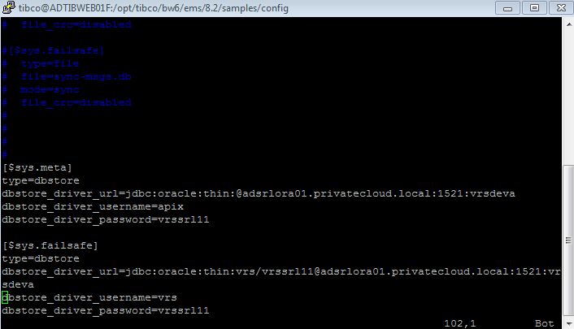

1. Associate destination with the configured stores.

setprop queue store.queue store= $sys.failsafe

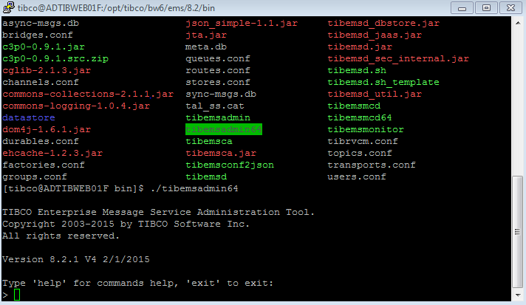

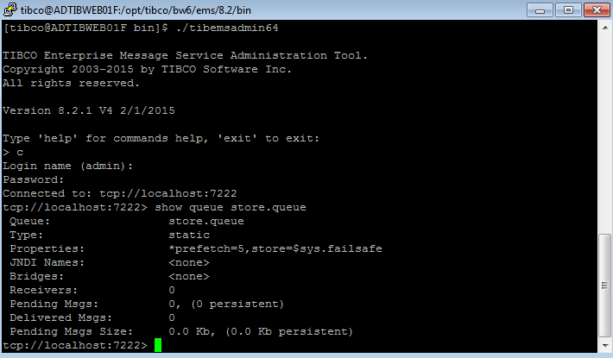

1. Set Path for Java.

Set the path in .bash_profile

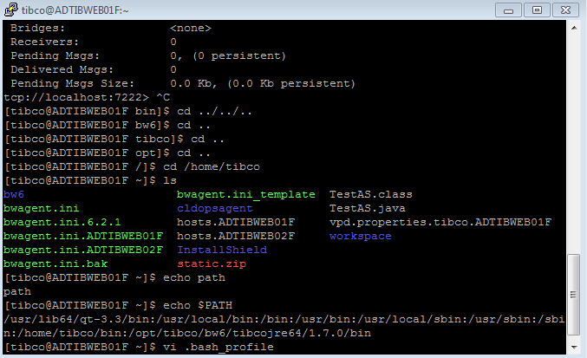

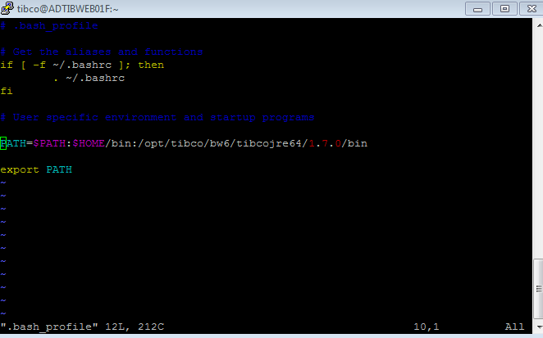

1. Export Database tables.

Java -jar /opt/tibco/bw6/ems/8.2/bin/tibemsd_util.jar -tibemsdconf /opt/tibco/bw6/ems/8.2/samples/config/tibemsd.conf -createall -export

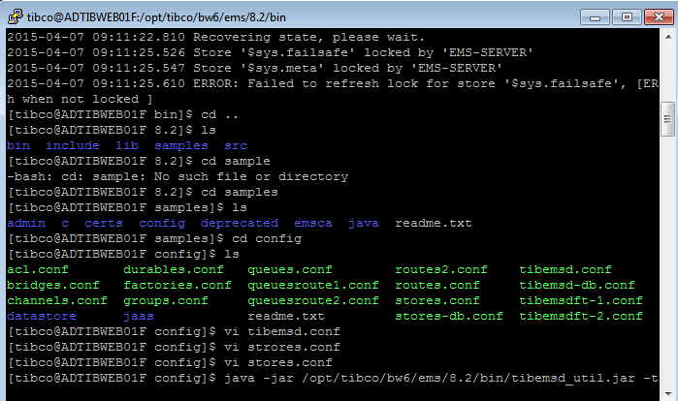

1. Start EMS server.

